The Effects of Zoom Self-View Distraction on Daily Self-Objectification and Well-Being

Randi L. Garcia1,2, Jessica Pardim Araujo1, Pamela Kramer1, & Sarah Bingham1

1 Psychology Department, Smith College

2 Program in Statistical and Data Sciences, Smith College

Author note

Smith College, Psychology Department, Smith College, Program in Statistical and Data Sciences.

The authors made the following contributions. Randi L. Garcia: Conceptualization, Methodology, Formal Analysis, Writing - Original Draft Preparation, Writing - Review & Editing, Supervision; Jessica Pardim Araujo: Writing - Original Draft Preparation, Formal Analysis, Writing - Review & Editing; Pamela Kramer: Formal Analysis, Writing - Review & Editing; Sarah Bingham: Conceptualization, Methodology.

Correspondence concerning this article should be addressed to Randi L. Garcia, College Lane, Smith College, Northampton, MA 01063. E-mail: [rgarcia@smith.edu](mailto:rgarcia@smith.edu)

Abstract

This study investigtaed the effects of using Zoom, specifically seeing oneself on Zoom on mental fatigue and general well-being.

*Keywords:* keywords

*Word count:* Zoom, self-objectification, computer mediated communication, authenticity

The Effects of Zoom Self-View Distraction on Daily Self-Objectification and Well-Being

Zoom –> SSO –> Authenticity –> well-being (cognition, well-being)

# Introduction Outline

* Problem
* Literature
  + Zoom Fatigue
  + Close paper on zoom and trait objectification
* Gap we are filling
  + 5-day daily diaries
  + State self-objectification
* Computer mediated interaction and self-objectification
  + Social media
  + Video chat (e.g Skype)
* State Self-Objectification
  + Authenticity
  + Well-being and cognition
* Zoom and well-being
  + Zoom fatigue
  + Cognitive fatigue
* Explaining reasons for the negative effects of Zoom
  + Self-objectification
  + Seeing yourself
  + Authenticity
  + Studies on self-verification; studies using mirror.

Teleworking and virtual meetings became the new reality for many individuals during the covid-19 lockdown. Although past research has shown video conferences as being positively correlated with higher productivity (Zornoza, Prieto, Martií & Peiroó, 1993 ), switching from in-person interactions in the workplace or academic environment to spending a significant part of the day in virtual meetings has been linked to what it been called Virtual Meeting fatigue — also known as Zoom fatigue (citation; Fosslien & Duffy, 2020; Jiang, 2020). While Zoom fatigue can be defined as physical and mental exhaustion due to spending long hours exposed to this technology, Nadler (2020) points out that Zoom fatigue is more than just screen staring and argues that much of it is due to the visual complexities of interpersonal interactions. Additionally, Nadler (2020) also proposed the third skin concept, which explains how video conference members are “flattened” into a third skin composed of persons, background, and technology. Similarly, Bailenson (2021) discusses how the nonverbal overload that does not happen in an in-person meeting, such as excessive amounts of close-up eye gaze, cognitive load, increased self-evaluation from staring at a video of oneself, and constraints on physical mobility, could be a potential cause for fatigue and other psychological consequences such as negative self-evaluation and cognitive overload.

Studies have found women to be more susceptible to zoom fatigue than men. (Ratan, Miller & Bailenson, J. N. 2022; Pfund GN, Hill PL, Harriger J, 2020; Shockley, K. M., Gabriel, A. S., Robertson, D., Rosen, C. C., Chawla, N., Ganster, M. L., & Ezerins, M. E. 2021). Ratan et al. (2022) study explain that facial dissatisfaction was found to be one of the reasons for higher zoom fatigue in women. Additionally, due to the possibility of being able to see oneself on screen, self-objectification was found to be another possible explanation of higher zoom fatigue, especially in women (Luo, Queiroz, Bailenson, Hancock, 2021; Pfund GN, Hill PL, Harriger J, 2020). In this study, we look into daily zoom use and how being distracted by one’s self-image through the self-view feature can increase the state of self-objectification in young women. Through a five-day daily diary, we investigate how zoom was related to authenticity and daily well-being. Moreover, this is the first study to explore trait self-objectification as a moderator of zoom usage and state self-objectification.

# Social Media and Self-Objectification

While there is a lack of self-objectification and other video chat interactions, such as skype, self-objectification in magazines, television and social media is a vast researched topic that can help us understand computer-mediated interactions relationship with self-objectification. Frederick and Robberts (1997) presented the objectification theory and defined self-objectification as feeling more like a body or an object rather than a human being. Past research has found that time spent on social media usage (e.g., Instagram, Facebook, Snapchat) and the use of its features (e.g., filter, likes, comments) are positively correlated to body dissatisfaction, eating disorders, appearance comparison, and self-objectification ( Bell, B. T., Cassarly, J. A., & Dunbar, L. 2018; Fardouly et al., 2015; Garcia, Bingham, & Liu 2021; Hanna et al., 2017; Pfund, Hill, and Harriger, 2020). Even though time was a predictor of self-objectification on social media, the same did not apply to Zoom. For instance, Harriger & Pfund (2022) found that the more time men and women spent on Zoom, the more appearance satisfaction was reported. However, the amount of time one spent looking at oneself was associated with appearance comparison and self-objectification. Thus, we could argue that being able to see oneself during video conferences could lead to social comparison with one’s image throughout the day and negative self-attention, which could increase Zoom fatigue.

State self-objectification (SSO) is a context-dependent condition that is triggered depending on the situation, for example, seeing sexualized images on social media or getting catcalled on the street. Trait self-objectification (TSO) is the internalized self-objectification throughout the years. Additionally, someone high in TSO is more prone to SSO (Fredrickson & Roberts, 1997; Gay & Castano, 2010). There are numerous cognitive and psychological consequences of being objectified. Even though some studies have shown that men are also self-objectifiers (see Daniel, Bridges, & Martens, 2014), women have more damaging and long-lasting consequences (Jones & Griffiths, 2015). For instance, studies have found that participants who present higher objectification reported feeling less authentic and having lower levels of subjective well-being in both workplace and academic settings (Cheng et al., 2022; Rollero, 2016). *add swimsuit study*

Additionally, Pfund, Hill, Harriger (2020) while using self-objectification as a moderator, found that being able to see oneself during a video call can increase ones self-objectification.

*use of the self-view feature has been linked to Being able to see oneself during meetings is also a door that leads to negative self-attention known as mirror anxiety.*

# Zoom and well-being

In the past years, researchers have been investigating the reasons that lead to zoom fatigue. For instance, Zoom meetings, differently from in-person, feature the possibility of looking at oneself during video calls through the feature known as “self-view.” Hence, because people are not used to viewing themselves when talking to others, the self-view feature can trigger thoughts and feelings that were not previously possible during in-person interactions and thus increasing fatigue (Fauville, G., Luo, M., Queiroz, A. C. M., Bailenson, J. N., & Hancock, J. 2021; Shockley, K. M., Gabriel, A. S., Robertson, D., Rosen, C. C., Chawla, N., Ganster, M. L., & Ezerins, M. E. 2021; Bailenson, J. N. 2021) ).

Ratan, Miller, and Bailenson (2022) explain how negative self-focused attention, known as mirror anxiety, leads to facial dissatisfaction and consequently increases Zoom fatigue.

# Zoom negative effects

For instance, Ratan, Miller, and Bailenson (2022), explains how negative self-focused attention, known as mirror anxiety, leads to facial dissatisfaction and consequently increases Zoom fatigue.

Past studies have found that using Zoom can cause mental fatigue (Bailenson, 2021). Seeing oneself on Zoom has also been linked to appearance concerns (Pfund et al., 2020).

# Methods

## Participants

## Measures

## Procedure

## Data analysis

We used R (Version 4.1.2; R Core Team, 2022) and the R-packages *dplyr* (Version 1.0.9; Wickham et al., 2021), *forcats* (Version 0.5.1; Wickham, 2021a), *ggplot2* (Version 3.3.6; Wickham, 2016), *lme4* (Version 1.1.27.1; Bates et al., 2015), *lmerTest* (Version 3.1.3; Kuznetsova et al., 2017), *Matrix* (Version 1.3.4; Bates & Maechler, 2021), *nlme* (Version 3.1.153; Pinheiro et al., 2021), *papaja* (Version 0.1.0.9999; Aust & Barth, 2022), *psych* (Version 2.1.9; Revelle, 2021), *purrr* (Version 0.3.4; Henry & Wickham, 2020), *readr* (Version 2.1.0; Wickham & Hester, 2020), *stringr* (Version 1.4.0; Wickham, 2019), *tibble* (Version 3.1.7; Müller & Wickham, 2021), *tidyr* (Version 1.2.0; Wickham, 2021b), *tidyverse* (Version 1.3.1; Wickham et al., 2019), and *tinylabels* (Version 0.2.3; Barth, 2022) for all our analyses.

# Results

## Zoom Use and State Self-Objectification

## daily_SSO daily_SSO_binary tso_mean OBCS_sur  
## daily_SSO 1.00000000 0.669651633 0.03813339 0.129034893  
## daily_SSO_binary 0.66965163 1.000000000 0.08455927 0.133948249  
## tso_mean 0.03813339 0.084559269 1.00000000 0.509816730  
## OBCS_sur 0.12903489 0.133948249 0.50981673 1.000000000  
## SPA 0.01420422 -0.004678395 0.38593126 0.635991331  
## Zoom_Total_Mins 0.11366899 0.098484033 -0.09266711 -0.132232776  
## Zoom_Use_Weekly 0.07773376 -0.031371983 -0.18508483 -0.126526116  
## Zoom_Use_Daily 0.10571735 -0.027760827 0.06465371 -0.127190827  
## Hide_Self_View -0.02587184 0.198546362 0.12282535 -0.004671422  
## Image_Distraction 0.10010665 -0.007788432 0.14806292 0.117445719  
## Hide_Self_View_Today 0.21461607 0.378339881 0.15627801 0.005227725  
## Self_Distraction_Today 0.32458884 0.196644793 0.14656102 0.132867310  
## SPA Zoom_Total_Mins Zoom_Use_Weekly  
## daily_SSO 0.014204220 0.113668986 0.07773376  
## daily_SSO_binary -0.004678395 0.098484033 -0.03137198  
## tso_mean 0.385931258 -0.092667107 -0.18508483  
## OBCS_sur 0.635991331 -0.132232776 -0.12652612  
## SPA 1.000000000 -0.006451003 -0.22790376  
## Zoom_Total_Mins -0.006451003 1.000000000 0.06138500  
## Zoom_Use_Weekly -0.227903761 0.061385004 1.00000000  
## Zoom_Use_Daily 0.042908228 0.130753584 0.13082707  
## Hide_Self_View 0.173510410 -0.089828387 -0.27143195  
## Image_Distraction 0.156316498 0.026528390 -0.01306277  
## Hide_Self_View_Today 0.041093694 -0.049584763 -0.20875119  
## Self_Distraction_Today 0.194822268 0.315559981 0.03132817  
## Zoom_Use_Daily Hide_Self_View Image_Distraction  
## daily_SSO 0.10571735 -0.025871843 0.100106650  
## daily_SSO_binary -0.02776083 0.198546362 -0.007788432  
## tso_mean 0.06465371 0.122825347 0.148062916  
## OBCS_sur -0.12719083 -0.004671422 0.117445719  
## SPA 0.04290823 0.173510410 0.156316498  
## Zoom_Total_Mins 0.13075358 -0.089828387 0.026528390  
## Zoom_Use_Weekly 0.13082707 -0.271431951 -0.013062770  
## Zoom_Use_Daily 1.00000000 0.077320990 -0.088831855  
## Hide_Self_View 0.07732099 1.000000000 -0.099508355  
## Image_Distraction -0.08883186 -0.099508355 1.000000000  
## Hide_Self_View_Today -0.01076344 0.529907315 -0.125012753  
## Self_Distraction_Today -0.02025397 -0.110297677 0.509468540  
## Hide_Self_View_Today Self_Distraction_Today  
## daily_SSO 0.214616070 0.32458884  
## daily_SSO_binary 0.378339881 0.19664479  
## tso_mean 0.156278013 0.14656102  
## OBCS_sur 0.005227725 0.13286731  
## SPA 0.041093694 0.19482227  
## Zoom_Total_Mins -0.049584763 0.31555998  
## Zoom_Use_Weekly -0.208751187 0.03132817  
## Zoom_Use_Daily -0.010763438 -0.02025397  
## Hide_Self_View 0.529907315 -0.11029768  
## Image_Distraction -0.125012753 0.50946854  
## Hide_Self_View_Today 1.000000000 -0.07263685  
## Self_Distraction_Today -0.072636848 1.00000000

## Generalized linear mixed model fit by maximum likelihood (Laplace  
## Approximation) [glmerMod]  
## Family: binomial ( logit )  
## Formula: daily_SSO_binary ~ day + Zoom_Total_Mins + (1 | partID)  
## Data: zoom_clean  
##   
## AIC BIC logLik deviance df.resid   
## 185.2 197.6 -88.6 177.2 162   
##   
## Scaled residuals:   
## Min 1Q Median 3Q Max   
## -3.2469 -0.4428 0.2167 0.3968 2.0676   
##   
## Random effects:  
## Groups Name Variance Std.Dev.  
## partID (Intercept) 6.005 2.451   
## Number of obs: 166, groups: partID, 37  
##   
## Fixed effects:  
## Estimate Std. Error z value Pr(>|z|)   
## (Intercept) 1.388783 0.878402 1.581 0.1139   
## day -0.298014 0.177565 -1.678 0.0933 .  
## Zoom_Total_Mins 0.002662 0.002428 1.096 0.2730   
## ---  
## Signif. codes: 0 '***' 0.001 '**' 0.01 '*' 0.05 '.' 0.1 ' ' 1  
##   
## Correlation of Fixed Effects:  
## (Intr) day   
## day -0.743   
## Zom_Ttl_Mns -0.519 0.248

## Linear mixed model fit by REML. t-tests use Satterthwaite's method [  
## lmerModLmerTest]  
## Formula: daily_SSO ~ day + Zoom_Total_Mins + (1 | partID)  
## Data: zoom_clean  
##   
## REML criterion at convergence: 597.9  
##   
## Scaled residuals:   
## Min 1Q Median 3Q Max   
## -1.8641 -0.4788 -0.1423 0.3692 3.7354   
##   
## Random effects:  
## Groups Name Variance Std.Dev.  
## partID (Intercept) 1.533 1.238   
## Residual 1.324 1.150   
## Number of obs: 166, groups: partID, 37  
##   
## Fixed effects:  
## Estimate Std. Error df t value Pr(>|t|)   
## (Intercept) 2.536e+00 3.570e-01 1.293e+02 7.103 7.29e-11 ***  
## day -1.085e-01 6.839e-02 1.331e+02 -1.586 0.115   
## Zoom_Total_Mins 1.137e-03 9.174e-04 1.510e+02 1.239 0.217   
## ---  
## Signif. codes: 0 '***' 0.001 '**' 0.01 '*' 0.05 '.' 0.1 ' ' 1  
##   
## Correlation of Fixed Effects:  
## (Intr) day   
## day -0.691   
## Zom_Ttl_Mns -0.565 0.329

## Linear mixed model fit by REML. t-tests use Satterthwaite's method [  
## lmerModLmerTest]  
## Formula: daily_SSO ~ day + Hide_Self_View_Today + Self_Distraction_Today +   
## (1 | partID)  
## Data: zoom_clean  
##   
## REML criterion at convergence: 594.2  
##   
## Scaled residuals:   
## Min 1Q Median 3Q Max   
## -2.1665 -0.4526 -0.1679 0.3987 3.9458   
##   
## Random effects:  
## Groups Name Variance Std.Dev.  
## partID (Intercept) 1.279 1.131   
## Residual 1.251 1.118   
## Number of obs: 171, groups: partID, 37  
##   
## Fixed effects:  
## Estimate Std. Error df t value Pr(>|t|)   
## (Intercept) 1.57159 0.45032 150.76703 3.490 0.000634 ***  
## day -0.08087 0.06425 136.43794 -1.259 0.210315   
## Hide_Self_View_Today 0.25845 0.08948 166.58432 2.888 0.004386 **   
## Self_Distraction_Today 0.20793 0.09968 166.50076 2.086 0.038502 *   
## ---  
## Signif. codes: 0 '***' 0.001 '**' 0.01 '*' 0.05 '.' 0.1 ' ' 1  
##   
## Correlation of Fixed Effects:  
## (Intr) day H_S_V_  
## day -0.598   
## Hd_Slf_Vw_T -0.478 0.070   
## Slf_Dstrc_T -0.658 0.289 0.053

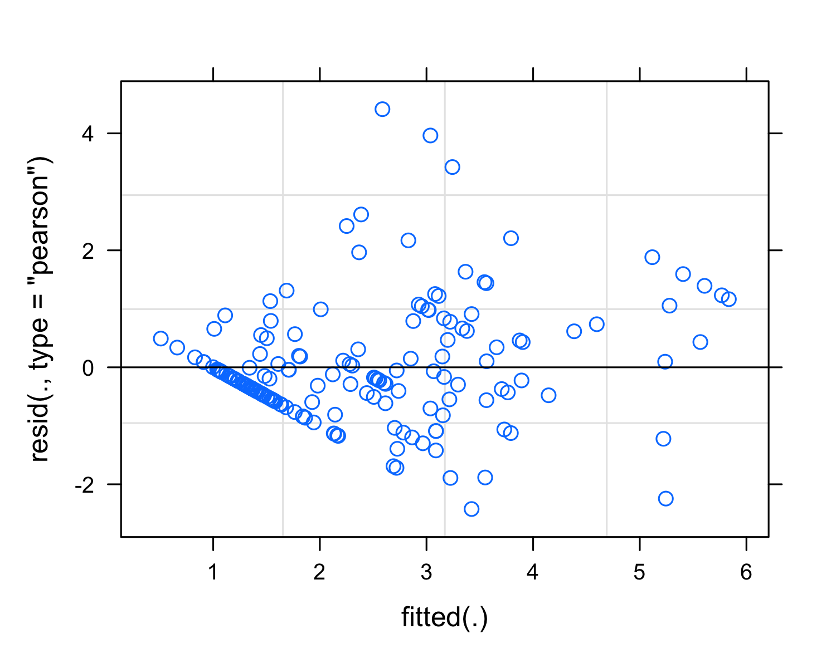

## Generalized linear mixed model fit by maximum likelihood (Laplace  
## Approximation) [glmerMod]  
## Family: binomial ( logit )  
## Formula:   
## daily_SSO_binary ~ day + Hide_Self_View_Today + Self_Distraction_Today +   
## (1 | partID)  
## Data: zoom_clean  
##   
## AIC BIC logLik deviance df.resid   
## 175.8 191.6 -82.9 165.8 166   
##   
## Scaled residuals:   
## Min 1Q Median 3Q Max   
## -3.9434 -0.4074 0.1714 0.3408 2.5391   
##   
## Random effects:  
## Groups Name Variance Std.Dev.  
## partID (Intercept) 4.499 2.121   
## Number of obs: 171, groups: partID, 37  
##   
## Fixed effects:  
## Estimate Std. Error z value Pr(>|z|)   
## (Intercept) -1.5033 1.1116 -1.352 0.17626   
## day -0.2198 0.1733 -1.268 0.20471   
## Hide_Self_View_Today 0.8500 0.2601 3.268 0.00108 **  
## Self_Distraction_Today 0.5396 0.2697 2.001 0.04536 *   
## ---  
## Signif. codes: 0 '***' 0.001 '**' 0.01 '*' 0.05 '.' 0.1 ' ' 1  
##   
## Correlation of Fixed Effects:  
## (Intr) day H_S_V_  
## day -0.584   
## Hd_Slf_Vw_T -0.478 -0.008   
## Slf_Dstrc_T -0.654 0.169 0.110

Interaction with TSO

## Generalized linear mixed model fit by maximum likelihood (Laplace  
## Approximation) [glmerMod]  
## Family: binomial ( logit )  
## Formula:   
## daily_SSO_binary ~ day + Hide_Self_View_Today * OBCS_sur + Self_Distraction_Today *   
## OBCS_sur + (1 | partID)  
## Data: zoom_clean  
##   
## AIC BIC logLik deviance df.resid   
## 179.9 205.1 -82.0 163.9 163   
##   
## Scaled residuals:   
## Min 1Q Median 3Q Max   
## -3.3900 -0.4136 0.1623 0.3529 2.8225   
##   
## Random effects:  
## Groups Name Variance Std.Dev.  
## partID (Intercept) 4.147 2.036   
## Number of obs: 171, groups: partID, 37  
##   
## Fixed effects:  
## Estimate Std. Error z value Pr(>|z|)  
## (Intercept) -0.23466 4.00808 -0.059 0.953  
## day -0.21474 0.17395 -1.234 0.217  
## Hide_Self_View_Today 0.51887 1.10773 0.468 0.639  
## OBCS_sur -0.25230 0.79716 -0.317 0.752  
## Self_Distraction_Today -0.56981 1.20541 -0.473 0.636  
## Hide_Self_View_Today:OBCS_sur 0.07135 0.22232 0.321 0.748  
## OBCS_sur:Self_Distraction_Today 0.21906 0.23631 0.927 0.354  
##   
## Correlation of Fixed Effects:  
## (Intr) day Hd_S_V_T OBCS_s Sl_D_T H_S_V_T:  
## day -0.153   
## Hd_Slf_Vw_T -0.554 -0.050   
## OBCS_sur -0.961 -0.012 0.555   
## Slf_Dstrc_T -0.687 0.086 0.020 0.661   
## H_S_V_T:OBC 0.540 0.050 -0.971 -0.573 -0.032   
## OBCS_:S_D_T 0.680 -0.046 -0.041 -0.696 -0.975 0.059

## Generalized linear mixed model fit by maximum likelihood (Laplace  
## Approximation) [glmerMod]  
## Family: binomial ( logit )  
## Formula:   
## daily_SSO_binary ~ day + Hide_Self_View_Today + Self_Distraction_Today +   
## OBCS_sur + (1 | partID)  
## Data: zoom_clean  
##   
## AIC BIC logLik deviance df.resid   
## 176.8 195.7 -82.4 164.8 165   
##   
## Scaled residuals:   
## Min 1Q Median 3Q Max   
## -3.8015 -0.4224 0.1822 0.3380 2.5084   
##   
## Random effects:  
## Groups Name Variance Std.Dev.  
## partID (Intercept) 4.286 2.07   
## Number of obs: 171, groups: partID, 37  
##   
## Fixed effects:  
## Estimate Std. Error z value Pr(>|z|)   
## (Intercept) -3.3770 2.1752 -1.553 0.12054   
## day -0.2156 0.1731 -1.246 0.21285   
## Hide_Self_View_Today 0.8580 0.2605 3.293 0.00099 ***  
## Self_Distraction_Today 0.5263 0.2685 1.960 0.04996 *   
## OBCS_sur 0.3869 0.3887 0.995 0.31957   
## ---  
## Signif. codes: 0 '***' 0.001 '**' 0.01 '*' 0.05 '.' 0.1 ' ' 1  
##   
## Correlation of Fixed Effects:  
## (Intr) day H_S_V_ Sl_D_T  
## day -0.276   
## Hd_Slf_Vw_T -0.311 -0.003   
## Slf_Dstrc_T -0.311 0.168 0.106   
## OBCS_sur -0.861 -0.026 0.077 -0.023

## Generalized linear mixed model fit by maximum likelihood (Laplace  
## Approximation) [glmerMod]  
## Family: binomial ( logit )  
## Formula:   
## daily_SSO_binary ~ day + Hide_Self_View_Today * tso_mean + Self_Distraction_Today *   
## tso_mean + (1 | partID)  
## Data: zoom_clean  
##   
## AIC BIC logLik deviance df.resid   
## 179.0 204.1 -81.5 163.0 163   
##   
## Scaled residuals:   
## Min 1Q Median 3Q Max   
## -2.8700 -0.3829 0.1576 0.3273 2.1989   
##   
## Random effects:  
## Groups Name Variance Std.Dev.  
## partID (Intercept) 4.967 2.229   
## Number of obs: 171, groups: partID, 37  
##   
## Fixed effects:  
## Estimate Std. Error z value Pr(>|z|)   
## (Intercept) -1.51922 1.16519 -1.304 0.19229   
## day -0.22457 0.17839 -1.259 0.20808   
## Hide_Self_View_Today 0.84200 0.27195 3.096 0.00196 **  
## tso_mean -0.46605 0.35265 -1.322 0.18631   
## Self_Distraction_Today 0.52544 0.27997 1.877 0.06055 .   
## Hide_Self_View_Today:tso_mean 0.07775 0.10703 0.726 0.46753   
## tso_mean:Self_Distraction_Today 0.15808 0.10825 1.460 0.14417   
## ---  
## Signif. codes: 0 '***' 0.001 '**' 0.01 '*' 0.05 '.' 0.1 ' ' 1  
##   
## Correlation of Fixed Effects:  
## (Intr) day Hd_S_V_T tso_mn Sl_D_T H_S_V_T:  
## day -0.561   
## Hd_Slf_Vw_T -0.490 -0.018   
## tso_mean 0.094 0.079 -0.086   
## Slf_Dstrc_T -0.663 0.163 0.123 -0.108   
## Hd_Sl_V_T:_ -0.021 -0.032 -0.032 -0.589 0.076   
## ts_mn:S_D_T -0.037 -0.087 0.085 -0.698 0.034 0.076

## Generalized linear mixed model fit by maximum likelihood (Laplace  
## Approximation) [glmerMod]  
## Family: binomial ( logit )  
## Formula:   
## daily_SSO_binary ~ day + Hide_Self_View_Today + Self_Distraction_Today +   
## tso_mean + (1 | partID)  
## Data: zoom_clean  
##   
## AIC BIC logLik deviance df.resid   
## 177.8 196.7 -82.9 165.8 165   
##   
## Scaled residuals:   
## Min 1Q Median 3Q Max   
## -3.9275 -0.4084 0.1716 0.3402 2.5375   
##   
## Random effects:  
## Groups Name Variance Std.Dev.  
## partID (Intercept) 4.501 2.122   
## Number of obs: 171, groups: partID, 37  
##   
## Fixed effects:  
## Estimate Std. Error z value Pr(>|z|)   
## (Intercept) -1.496381 1.120484 -1.335 0.18172   
## day -0.219685 0.173288 -1.268 0.20489   
## Hide_Self_View_Today 0.848529 0.261710 3.242 0.00119 **  
## Self_Distraction_Today 0.538329 0.270928 1.987 0.04692 *   
## tso_mean 0.007804 0.159002 0.049 0.96085   
## ---  
## Signif. codes: 0 '***' 0.001 '**' 0.01 '*' 0.05 '.' 0.1 ' ' 1  
##   
## Correlation of Fixed Effects:  
## (Intr) day H_S_V_ Sl_D_T  
## day -0.579   
## Hd_Slf_Vw_T -0.485 -0.008   
## Slf_Dstrc_T -0.658 0.168 0.120   
## tso_mean 0.126 0.006 -0.110 -0.097

## Generalized linear mixed model fit by maximum likelihood (Laplace  
## Approximation) [glmerMod]  
## Family: binomial ( logit )  
## Formula:   
## daily_SSO_binary ~ day + Hide_Self_View_Today + Self_Distraction_Today *   
## SPA + (1 | partID)  
## Data: zoom_clean  
##   
## AIC BIC logLik deviance df.resid   
## 177.9 199.9 -82.0 163.9 164   
##   
## Scaled residuals:   
## Min 1Q Median 3Q Max   
## -2.8579 -0.4136 0.1594 0.3368 2.8075   
##   
## Random effects:  
## Groups Name Variance Std.Dev.  
## partID (Intercept) 4.253 2.062   
## Number of obs: 171, groups: partID, 37  
##   
## Fixed effects:  
## Estimate Std. Error z value Pr(>|z|)   
## (Intercept) 2.2378 3.1856 0.702 0.482381   
## day -0.2225 0.1740 -1.278 0.201102   
## Hide_Self_View_Today 0.8753 0.2646 3.308 0.000939 ***  
## Self_Distraction_Today -1.0016 1.1613 -0.863 0.388403   
## SPA -1.1204 0.8969 -1.249 0.211579   
## Self_Distraction_Today:SPA 0.4490 0.3328 1.349 0.177281   
## ---  
## Signif. codes: 0 '***' 0.001 '**' 0.01 '*' 0.05 '.' 0.1 ' ' 1  
##   
## Correlation of Fixed Effects:  
## (Intr) day H_S_V_ Sl_D_T SPA   
## day -0.256   
## Hd_Slf_Vw_T -0.066 -0.028   
## Slf_Dstrc_T -0.777 0.110 -0.098   
## SPA -0.937 0.059 -0.106 0.774   
## Slf_D_T:SPA 0.754 -0.074 0.129 -0.972 -0.807

## Generalized linear mixed model fit by maximum likelihood (Laplace  
## Approximation) [glmerMod]  
## Family: binomial ( logit )  
## Formula:   
## daily_SSO_binary ~ day + Hide_Self_View_Today + Self_Distraction_Today +   
## SPA + (1 | partID)  
## Data: zoom_clean  
##   
## AIC BIC logLik deviance df.resid   
## 177.8 196.6 -82.9 165.8 165   
##   
## Scaled residuals:   
## Min 1Q Median 3Q Max   
## -4.0517 -0.4151 0.1709 0.3408 2.5596   
##   
## Random effects:  
## Groups Name Variance Std.Dev.  
## partID (Intercept) 4.447 2.109   
## Number of obs: 171, groups: partID, 37  
##   
## Fixed effects:  
## Estimate Std. Error z value Pr(>|z|)   
## (Intercept) -1.0051 2.1090 -0.477 0.63366   
## day -0.2196 0.1731 -1.269 0.20461   
## Hide_Self_View_Today 0.8502 0.2591 3.281 0.00103 **  
## Self_Distraction_Today 0.5462 0.2704 2.020 0.04340 *   
## SPA -0.1495 0.5374 -0.278 0.78081   
## ---  
## Signif. codes: 0 '***' 0.001 '**' 0.01 '*' 0.05 '.' 0.1 ' ' 1  
##   
## Correlation of Fixed Effects:  
## (Intr) day H_S_V_ Sl_D_T  
## day -0.317   
## Hd_Slf_Vw_T -0.238 -0.009   
## Slf_Dstrc_T -0.262 0.168 0.110   
## SPA -0.850 0.011 -0.015 -0.095

## Daliy State Self-Objectification and Outcomes

## daily_SSO daily_SSO_binary stroop_fatigue How_Today  
## daily_SSO 1.00000000 0.6696516 0.064117126 -0.32193254  
## daily_SSO_binary 0.66965163 1.0000000 0.110901624 -0.17486338  
## stroop_fatigue 0.06411713 0.1109016 1.000000000 -0.06875165  
## How_Today -0.32193254 -0.1748634 -0.068751651 1.00000000  
## Mental_Fatigue_Daily 0.51262027 0.2908240 0.005935582 -0.45600601  
## authenticity -0.34573714 -0.1333058 -0.114906943 0.30883100  
## interact_qual -0.43868140 -0.1925384 -0.107170686 0.45281903  
## SES_daily -0.47940717 -0.3637374 -0.060073473 0.53430510  
## Mental_Fatigue_Daily authenticity interact_qual  
## daily_SSO 0.512620271 -0.3457371 -0.4386814  
## daily_SSO_binary 0.290824000 -0.1333058 -0.1925384  
## stroop_fatigue 0.005935582 -0.1149069 -0.1071707  
## How_Today -0.456006012 0.3088310 0.4528190  
## Mental_Fatigue_Daily 1.000000000 -0.2639803 -0.2935074  
## authenticity -0.263980273 1.0000000 0.6825420  
## interact_qual -0.293507381 0.6825420 1.0000000  
## SES_daily -0.557131228 0.2945053 0.3554374  
## SES_daily  
## daily_SSO -0.47940717  
## daily_SSO_binary -0.36373737  
## stroop_fatigue -0.06007347  
## How_Today 0.53430510  
## Mental_Fatigue_Daily -0.55713123  
## authenticity 0.29450534  
## interact_qual 0.35543742  
## SES_daily 1.00000000

State Self-Objectification to authenticity and interaction quality.

## Linear mixed model fit by REML. t-tests use Satterthwaite's method [  
## lmerModLmerTest]  
## Formula: authenticity ~ daily_SSO + day + (1 | partID)  
## Data: zoom_clean  
##   
## REML criterion at convergence: 611.4  
##   
## Scaled residuals:   
## Min 1Q Median 3Q Max   
## -3.1873 -0.4947 0.1654 0.5765 1.9746   
##   
## Random effects:  
## Groups Name Variance Std.Dev.  
## partID (Intercept) 0.6445 0.8028   
## Residual 1.6579 1.2876   
## Number of obs: 170, groups: partID, 37  
##   
## Fixed effects:  
## Estimate Std. Error df t value Pr(>|t|)   
## (Intercept) 4.970928 0.339039 135.418752 14.662 < 2e-16 ***  
## daily_SSO -0.271519 0.077017 138.596400 -3.525 0.000574 ***  
## day 0.008372 0.071665 135.234453 0.117 0.907175   
## ---  
## Signif. codes: 0 '***' 0.001 '**' 0.01 '*' 0.05 '.' 0.1 ' ' 1  
##   
## Correlation of Fixed Effects:  
## (Intr) dl_SSO  
## daily_SSO -0.620   
## day -0.689 0.131

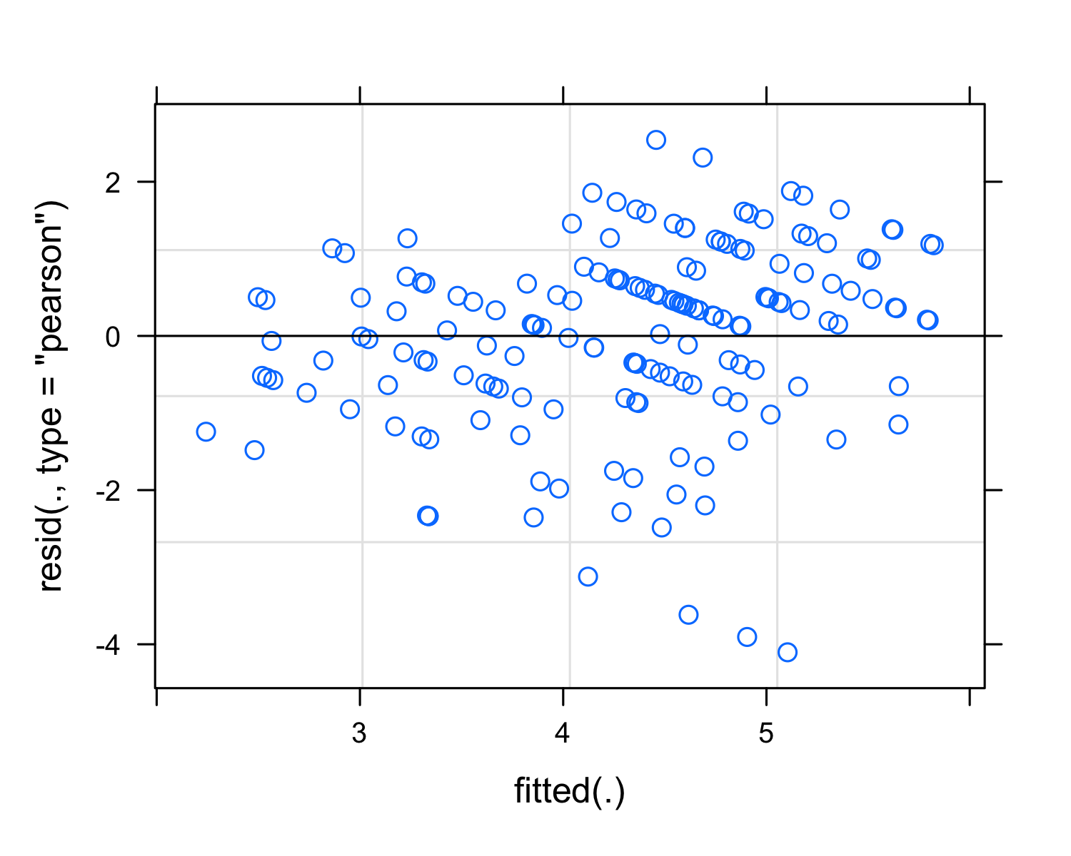

## Linear mixed model fit by REML. t-tests use Satterthwaite's method [  
## lmerModLmerTest]  
## Formula: interact_qual ~ daily_SSO + day + (1 | partID)  
## Data: zoom_clean  
##   
## REML criterion at convergence: 406.7  
##   
## Scaled residuals:   
## Min 1Q Median 3Q Max   
## -3.07232 -0.49077 0.03079 0.58778 2.33422   
##   
## Random effects:  
## Groups Name Variance Std.Dev.  
## partID (Intercept) 0.2450 0.4950   
## Residual 0.4893 0.6995   
## Number of obs: 167, groups: partID, 37  
##   
## Fixed effects:  
## Estimate Std. Error df t value Pr(>|t|)   
## (Intercept) 5.14374 0.19094 131.39902 26.939 < 2e-16 ***  
## daily_SSO -0.21801 0.04332 145.86507 -5.033 1.4e-06 ***  
## day 0.05243 0.03979 131.63149 1.317 0.19   
## ---  
## Signif. codes: 0 '***' 0.001 '**' 0.01 '*' 0.05 '.' 0.1 ' ' 1  
##   
## Correlation of Fixed Effects:  
## (Intr) dl_SSO  
## daily_SSO -0.615   
## day -0.668 0.122

Interaction quality (and SSO) and Well-Being

## Linear mixed model fit by REML. t-tests use Satterthwaite's method [  
## lmerModLmerTest]  
## Formula: stroop_fatigue ~ interact_qual + daily_SSO + day + (1 | partID)  
## Data: zoom_clean  
##   
## REML criterion at convergence: 1099.1  
##   
## Scaled residuals:   
## Min 1Q Median 3Q Max   
## -2.5739 -0.5918 -0.1440 0.4195 5.0122   
##   
## Random effects:  
## Groups Name Variance Std.Dev.  
## partID (Intercept) 4.71 2.170   
## Residual 47.42 6.887   
## Number of obs: 163, groups: partID, 37  
##   
## Fixed effects:  
## Estimate Std. Error df t value Pr(>|t|)   
## (Intercept) 10.97867 3.91942 144.13734 2.801 0.00579 **  
## interact_qual -0.54378 0.69129 143.93521 -0.787 0.43280   
## daily_SSO 0.04771 0.38992 107.43441 0.122 0.90285   
## day -0.44295 0.39804 133.39557 -1.113 0.26778   
## ---  
## Signif. codes: 0 '***' 0.001 '**' 0.01 '*' 0.05 '.' 0.1 ' ' 1  
##   
## Correlation of Fixed Effects:  
## (Intr) intrc_ dl_SSO  
## interact_ql -0.910   
## daily_SSO -0.587 0.404   
## day -0.222 -0.097 0.031

## Linear mixed model fit by REML. t-tests use Satterthwaite's method [  
## lmerModLmerTest]  
## Formula: How_Today ~ interact_qual + daily_SSO + day + (1 | partID)  
## Data: zoom_clean  
##   
## REML criterion at convergence: 523.9  
##   
## Scaled residuals:   
## Min 1Q Median 3Q Max   
## -2.4678 -0.6050 0.0134 0.6761 2.5977   
##   
## Random effects:  
## Groups Name Variance Std.Dev.  
## partID (Intercept) 0.03099 0.176   
## Residual 1.24587 1.116   
## Number of obs: 167, groups: partID, 37  
##   
## Fixed effects:  
## Estimate Std. Error df t value Pr(>|t|)   
## (Intercept) 1.82865 0.60105 136.40386 3.042 0.00282 **   
## interact_qual 0.50434 0.10548 131.94925 4.781 4.58e-06 ***  
## daily_SSO -0.12378 0.05874 94.15094 -2.107 0.03774 *   
## day 0.12084 0.06298 136.86015 1.919 0.05708 .   
## ---  
## Signif. codes: 0 '***' 0.001 '**' 0.01 '*' 0.05 '.' 0.1 ' ' 1  
##   
## Correlation of Fixed Effects:  
## (Intr) intrc_ dl_SSO  
## interact_ql -0.912   
## daily_SSO -0.602 0.428   
## day -0.231 -0.093 0.025

## Linear mixed model fit by REML. t-tests use Satterthwaite's method [  
## lmerModLmerTest]  
## Formula: Mental_Fatigue_Daily ~ interact_qual + daily_SSO + day + (1 |   
## partID)  
## Data: zoom_clean  
##   
## REML criterion at convergence: 474.1  
##   
## Scaled residuals:   
## Min 1Q Median 3Q Max   
## -2.3978 -0.5890 -0.0573 0.6396 3.4795   
##   
## Random effects:  
## Groups Name Variance Std.Dev.  
## partID (Intercept) 0.5666 0.7527   
## Residual 0.6714 0.8194   
## Number of obs: 167, groups: partID, 37  
##   
## Fixed effects:  
## Estimate Std. Error df t value Pr(>|t|)   
## (Intercept) 3.28238 0.54317 162.72993 6.043 9.97e-09 ***  
## interact_qual -0.13737 0.09484 159.85765 -1.448 0.14948   
## daily_SSO 0.28757 0.05749 162.55542 5.002 1.46e-06 ***  
## day -0.12738 0.04703 130.08653 -2.708 0.00767 **   
## ---  
## Signif. codes: 0 '***' 0.001 '**' 0.01 '*' 0.05 '.' 0.1 ' ' 1  
##   
## Correlation of Fixed Effects:  
## (Intr) intrc_ dl_SSO  
## interact_ql -0.895   
## daily_SSO -0.564 0.348   
## day -0.184 -0.106 0.089

## Linear mixed model fit by REML. t-tests use Satterthwaite's method [  
## lmerModLmerTest]  
## Formula: SES_daily ~ interact_qual + daily_SSO + day + (1 | partID)  
## Data: zoom_clean  
##   
## REML criterion at convergence: 207  
##   
## Scaled residuals:   
## Min 1Q Median 3Q Max   
## -2.35540 -0.43496 0.03415 0.56821 2.98927   
##   
## Random effects:  
## Groups Name Variance Std.Dev.  
## partID (Intercept) 0.06438 0.2537   
## Residual 0.14411 0.3796   
## Number of obs: 167, groups: partID, 37  
##   
## Fixed effects:  
## Estimate Std. Error df t value Pr(>|t|)   
## (Intercept) 2.52215 0.23914 162.25849 10.547 < 2e-16 ***  
## interact_qual 0.08054 0.04202 162.85183 1.917 0.0570 .   
## daily_SSO -0.10130 0.02495 151.47362 -4.060 7.83e-05 ***  
## day 0.05434 0.02169 133.63433 2.505 0.0134 *   
## ---  
## Signif. codes: 0 '***' 0.001 '**' 0.01 '*' 0.05 '.' 0.1 ' ' 1  
##   
## Correlation of Fixed Effects:  
## (Intr) intrc_ dl_SSO  
## interact_ql -0.904   
## daily_SSO -0.578 0.370   
## day -0.195 -0.102 0.072

# Discussion

# References

Aust, F., & Barth, M. (2022). *papaja: Prepare reproducible APA journal articles with R Markdown*. <https://github.com/crsh/papaja>

Bailenson, J. N. (2021). *Nonverbal overload: A theoretical argument for the causes of zoom fatigue*.

Barth, M. (2022). *tinylabels: Lightweight variable labels*. <https://cran.r-project.org/package=tinylabels>

Bates, D., Mächler, M., Bolker, B., & Walker, S. (2015). Fitting linear mixed-effects models using lme4. *Journal of Statistical Software*, *67*(1), 1–48. <https://doi.org/10.18637/jss.v067.i01>

Bates, D., & Maechler, M. (2021). *Matrix: Sparse and dense matrix classes and methods*. <https://CRAN.R-project.org/package=Matrix>

Henry, L., & Wickham, H. (2020). *Purrr: Functional programming tools*. <https://CRAN.R-project.org/package=purrr>

Kuznetsova, A., Brockhoff, P. B., & Christensen, R. H. B. (2017). lmerTest package: Tests in linear mixed effects models. *Journal of Statistical Software*, *82*(13), 1–26. <https://doi.org/10.18637/jss.v082.i13>

Müller, K., & Wickham, H. (2021). *Tibble: Simple data frames*. <https://CRAN.R-project.org/package=tibble>

Pfund, G. N., Hill, P. L., & Harriger, J. (2020). Video chatting and appearance satisfaction during COVID-19: Appearance comparisons and self-objectification as moderators. *International Journal of Eating Disorders*, *53*(12), 2038–2043.

Pinheiro, J., Bates, D., DebRoy, S., Sarkar, D., & R Core Team. (2021). *nlme: Linear and nonlinear mixed effects models*. <https://CRAN.R-project.org/package=nlme>

R Core Team. (2022). *R: A language and environment for statistical computing*. R Foundation for Statistical Computing. <https://www.R-project.org/>

Revelle, W. (2021). *Psych: Procedures for psychological, psychometric, and personality research*. Northwestern University. <https://CRAN.R-project.org/package=psych>

Wickham, H. (2016). *ggplot2: Elegant graphics for data analysis*. Springer-Verlag New York. <https://ggplot2.tidyverse.org>

Wickham, H. (2019). *Stringr: Simple, consistent wrappers for common string operations*. <https://CRAN.R-project.org/package=stringr>

Wickham, H. (2021a). *Forcats: Tools for working with categorical variables (factors)*. <https://CRAN.R-project.org/package=forcats>

Wickham, H. (2021b). *Tidyr: Tidy messy data*. <https://CRAN.R-project.org/package=tidyr>

Wickham, H., Averick, M., Bryan, J., Chang, W., McGowan, L. D., François, R., Grolemund, G., Hayes, A., Henry, L., Hester, J., Kuhn, M., Pedersen, T. L., Miller, E., Bache, S. M., Müller, K., Ooms, J., Robinson, D., Seidel, D. P., Spinu, V., … Yutani, H. (2019). Welcome to the tidyverse. *Journal of Open Source Software*, *4*(43), 1686. <https://doi.org/10.21105/joss.01686>

Wickham, H., François, R., Henry, L., & Müller, K. (2021). *Dplyr: A grammar of data manipulation*. <https://CRAN.R-project.org/package=dplyr>

Wickham, H., & Hester, J. (2020). *Readr: Read rectangular text data*. <https://CRAN.R-project.org/package=readr>